8TH YEARS ANNIVERSARY

OF
Jesus the way ,the truth and the Life.John 14:6
29th-30thMay,2010.Time:Saturday,5.00pm.Sunday,2.00pm.

You are Invited.
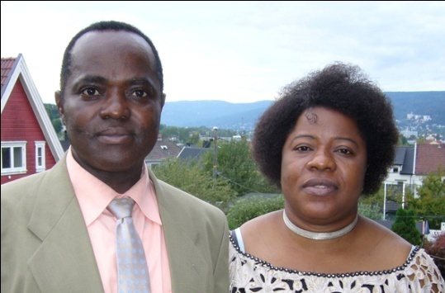 God is Love. 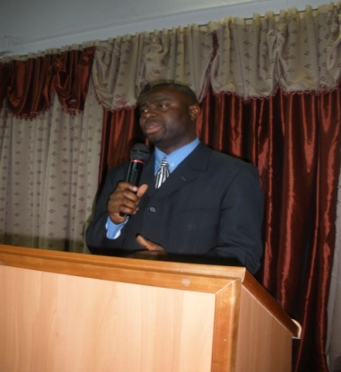
Host:Pastor Rayne & Florence. Norway. Pastor Kelly.Spain

Win Drammen For God As both pastors Agreed.For the Bible says;Again I say to you that If two of you shall agree on earth concerning anything that they ask,it will be done for them by my Father in Heaven.Math 18:19.

Now is the Time of God Visitation in your Life.
Many other Men and Women of God are invited to Ignite you with the Fire of God.
Venue:At The Christian Faith Gospel Church Auditorium .C/o Baptist Church,
Torgeir Vraas Plass 7,Strømsø,3044 Drammen.
For More Information Call:90068382/98604641.
Visit our website:www.rayneusen.com.

