Welcome to our Edition.

Topic:The fear of the Lord.

Fear is emotion caused by impending danger or pain e.t.c but the fear of the Lord we are talking about here is Revere which mean,regard with deep and affectionate or religious respect,
In order word Revere God.
The Bible says in the book of prov.19:23.The fear of the Lord leads to life,And he who has it will abide in satisfaction
He will not be visited with evil.
Praise the Lord,Hallelujah.
Let us look at this verse in three ways;
1.The Lord says,when you have His fear in you, you will have life in you.
2. The Lord says, when you have His fear in you, you will abide in satisfaction.
3. The Lord says,when you have His fear in you, you will not be visited with evil. Amen.
How wonderful is the promises of God to his people.I deeply believe that the promises of God to His people must come to pass.How ? You may ask.
1.By believing it.
2.By meditating on it.
3.By claiming it.
4.By confessing it.
5. By accepting it and thanking God for His mercies toward you.
Again looking at this verse, It`s pertinent to note that evil can visit people.That is not your portion in Jesus `Name.One can have satisfactoin and can have life.May these be your portion in Jesus`Name.Before we can be a part of these blessings, we must have the fear of the Lord.Thank you Lord for giving us the understanding on how your promises can fulfill in our lifes. Amen.

Testimonies .
For with God nothing will be impossible;Luke 1:37.
Satan, you are a liar says sister Cecilia,who saw her daughter lying down flat on the floor,what come to my mind is the blood of Jesus,laying hand on her and I began to plead the blood of Jesus.Sudenly she rose and said mamma I am healed. Praise the Lord.

Praise the Lord,Hallelujah.
I want to thank God for His protection and for seeing me through in my Master`s programme.
Kamitanji.

Praise the Lord.Amen.
I am a Qualified Nurse from Africa. I attended School of Nursing for three Years.I came to Norway and send my certificate to the Authority for
Authorization.I was told that my certificate is not accepted and that I should take the course again.what come to me.is that this is the work of the devil.I started to pray a dangerious prayer. I however pick up courage to start the course,but I never give up in praying.After two weeks, I received a call from Authority that my certificate had been accepted without doubt.
Sister Kavira.

Praise the Lord.Hallelujah.

Do not worry:
”So why do you worry about clothing ?Consider the lilies of the field,how they grow,they
neither toil nor spin.” Math 6:28

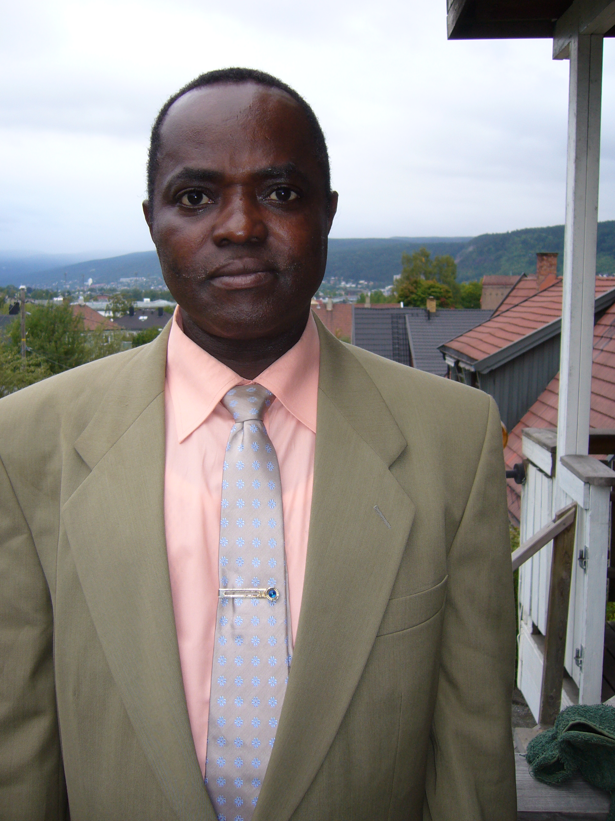

May God bless you all.
Pastor Rayne Usen.

